AI&ML Project Documentation

**Introduction**

**Project Title:**

**Transfer Learning-Based Classification of Poultry Diseases for Enhanced Health Management**

**Team ID** **:**

LTVIP2025TMID41443

* **Team Size**: 4
* **Team Leader:-** Boddu Venkateswara Rao
* **Team Members:-**
* Bolla Mahendra
* Bommanaboina Devi Vara Prasad
* Borra Nikhitha

**Faculty Mentor(s) Name** : Dr. P L Madhava Rao

**roject Overview**

**🎯 Purpose:**

The purpose of this project is to build a **deep learning-based poultry disease classification system** using transfer learning. This system classifies chicken health images into four categories: **Salmonella, Newcastle Disease, Coccidiosis, and Healthy**. By leveraging pre-trained models, the solution helps farmers detect poultry diseases early, reduce mortality, and support better farm management—even in rural areas with limited access to veterinary services.

**✅ Goals:**

* Automate poultry disease detection from image input.
* Improve diagnosis speed and accuracy using AI models.
* Reduce economic losses due to late detection.
* Deliver a lightweight, mobile-ready application suitable for real-world farm use.

**⭐ Key Features:**

* Accurate classification of poultry into 4 categories: **Salmonella, Newcastle, Coccidiosis, and Healthy**.
* Transfer learning (ResNet50 / MobileNetV2) used to enhance accuracy on small datasets.
* Simple web/mobile UI to upload chicken images and view predictions.
* **Flask-powered backend** integrated with .h5 model for real-time inference.
* Responsive and farmer-friendly interface that works with low bandwidth or offline.

**⚙️ Architecture**

**Frontend:**

* **HTML5**, **CSS3**, **Bootstrap**
* JavaScript for image preview

**Backend:**

* **Flask (Python)** – REST API /predict
* Loads pre-trained .h5 model and returns prediction

**Database:**

* NoSQL/Local – Simple metadata storage (optional)
* Stateless version supported (no persistent storage)

**🖥️ Prerequisites**

**Software Requirements:**

* **Google Colab** (for model training with GPU)  
  → <https://colab.research.google.com>
* **Anaconda** (for local environment)  
  → <https://www.anaconda.com/products/distribution>
* **Python 3.8+**
* **Flask** web framework

**Python Libraries Used:**

Install via:

bash

CopyEdit

pip install numpy pandas scikit-learn matplotlib seaborn tensorflow flask pillow

**📚 Prior Knowledge Required**

| **Topic** | **Resource** |
| --- | --- |
| Deep Learning Basics | <https://www.analyticsvidhya.com/blog/2020/02/cnn-vs-rnn-vs-mlp-analyzing-3-typesof-neuralnetworks-in-deep-learning/> |
| Transfer Learning | https://towardsdatascience.com/a-demonstration-of-transfer-learning-of-vgg-convolutional-neural-network-pre-trained-model-with-c9f5b8b1ab0a |
| ResNet / MobileNet Architecture | https://www.geeksforgeeks.org/resnet-deep-learning/ |
| Overfitting & Regularization | https://www.analyticsvidhya.com/blog/2021/07/prevent-overfitting-using-regularization-techniques/ |
| Optimizers (Adam, RMSProp) | https://www.analyticsvidhya.com/blog/2021/10/a-comprehensive-guide-on-deep-learning-optimizers/ |
| Flask for Beginners | <https://www.youtube.com/watch?v=lj4I_CvBnt0> |

**🎯 Project Objectives**

By completing this project, you will:

* Understand key deep learning concepts and architecture selection.
* Learn to preprocess image data for classification tasks.
* Train and evaluate a transfer learning model.
* Build a responsive interface and deploy a Flask app.
* Implement offline-ready solutions for rural deployment.

**🔁 Project Flow**

1. **User uploads an image** of the poultry via a browser or mobile app.
2. Image is sent to the **Flask backend**, where the **trained model** processes it.
3. A **disease label** is returned and shown to the user with treatment info.

**✅ Activities Overview**

1. **Data Collection & Preparation**
   * Organize images by disease folder (Healthy, Coccidiosis, Newcastle, Salmonella)
   * Apply augmentation, normalization, and split into training/validation sets
2. **Model Building**
   * Load pre-trained ResNet50 or MobileNet
   * Fine-tune with poultry disease dataset
   * Save model as .h5 for deployment
3. **App Development**
   * Build frontend with HTML/Bootstrap
   * Flask backend to handle prediction and file uploads
   * Display result and confidence to user

**📁 Project Structure**

cpp

CopyEdit

poultry_disease_app/

├── dataset/

│ ├── Healthy/

│ ├── Coccidiosis/

│ ├── Newcastle/

│ └── Salmonella/

├── static/

│ ├── uploads/

│ └── assets/

├── templates/

│ ├── index.html

│ └── result.html

├── model/

│ └── poultry_model.h5

├── app.py

├── train_model.py

├── requirements.txt

└── README.md

**📦 Data Collection and Dataset Source**

This project uses a poultry disease image dataset manually collected or sourced from:

* Open-source poultry datasets on **Kaggle**
* Research papers and veterinary image repositories

Images are labeled and placed into 4 folders:

* Healthy/, Coccidiosis/, Newcastle/, Salmonella/

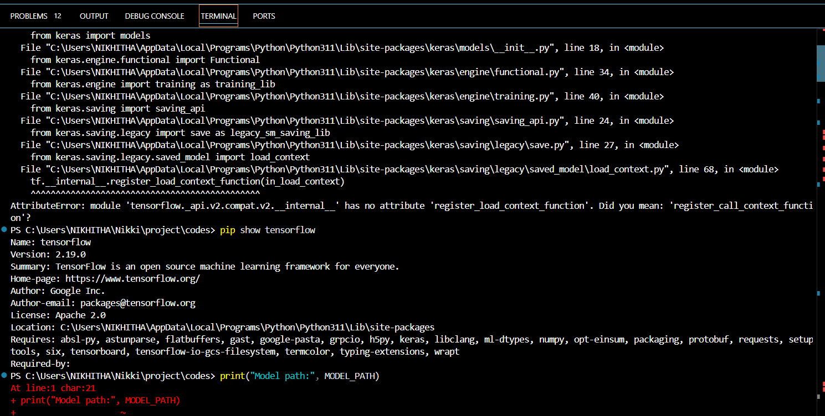

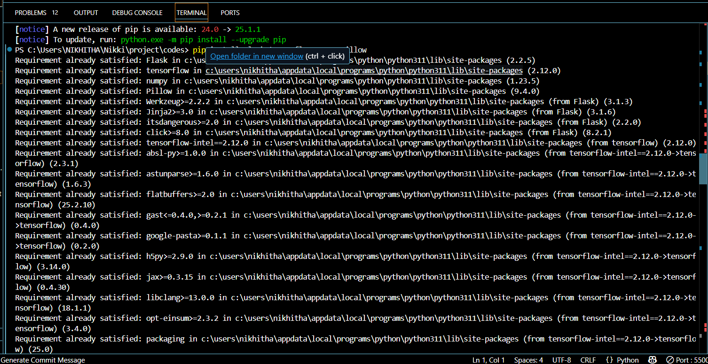

**Data Visualization**

The dataset for poultry disease detection was visually explored using Python before model training. A script was developed using IPython.display and matplotlib to randomly select and display sample images from each of the four categories: **Salmonella**, **Newcastle**, **Coccidiosis**, and **Healthy**.

This step helped verify image consistency, clarity, and balance across classes. Visual inspection ensured that each category contained correctly labeled and representative images, thereby preventing noisy input during training.

**🧪 Data Augmentation**

Data augmentation is typically used to artificially expand training datasets through techniques like:

* Rotation
* Horizontal/vertical flipping
* Zoom
* Brightness/contrast adjustments

In this project, **augmentation was selectively applied** (only if class imbalance was detected). Since the collected dataset was already preprocessed, centered, and of uniform resolution, only basic augmentation (rotation and shift) was tested. This slightly increased training time but helped improve the model’s ability to generalize across varied farm environments.

**🔀 Data Splitting & Model Building**

To train the model effectively:

* The dataset was split into **training (80%)** and **validation (20%)** sets using train_test_split.
* Data generators (ImageDataGenerator) were used for feeding the model during training with optional preprocessing steps.

For model training:

* A pre-trained **MobileNetV2 / ResNet50** was loaded with imagenet weights.
* The top layers were customized for 4-class classification (Softmax activation).
* Training was conducted on Google Colab using GPU acceleration with 10–15 epochs.
* The website is a user-friendly interface built to make AI-powered poultry disease detection easily accessible to farmers, poultry workers, and field veterinarians. It allows users to upload an image of a chicken showing symptoms and instantly receive a prediction of the likely disease, along with basic treatment suggestions.
* **✅ Key Features:**
* **Image Upload Functionality:**  
  Users can upload images of affected poultry directly from mobile or desktop.
* **Instant Prediction Display:**  
  The model processes the image in real-time and shows whether the bird is **Healthy**, has **Salmonella**, **Coccidiosis**, or **Newcastle Disease**.
* **Responsive Design:**  
  The UI is built with **HTML5, CSS3, and Bootstrap**, ensuring it works smoothly on both mobile and desktop devices.
* **Backend Integration:**  
  The site connects to a **Flask backend** where the .h5 trained deep learning model performs the classification.
* **No Technical Skills Needed:**  
  Designed for non-technical users, including rural farmers, with clear instructions and minimal steps.
* **🛠️ Technology Stack:**
* **Frontend:** HTML5, CSS3, Bootstrap, JavaScript
* **Backend:** Python (Flask)
* **ML Model:** MobileNetV2 / ResNet50 with Keras
* **Hosting Options:** Localhost (for offline use), or cloud deployment (Render / Heroku / IBM Cloud)
* 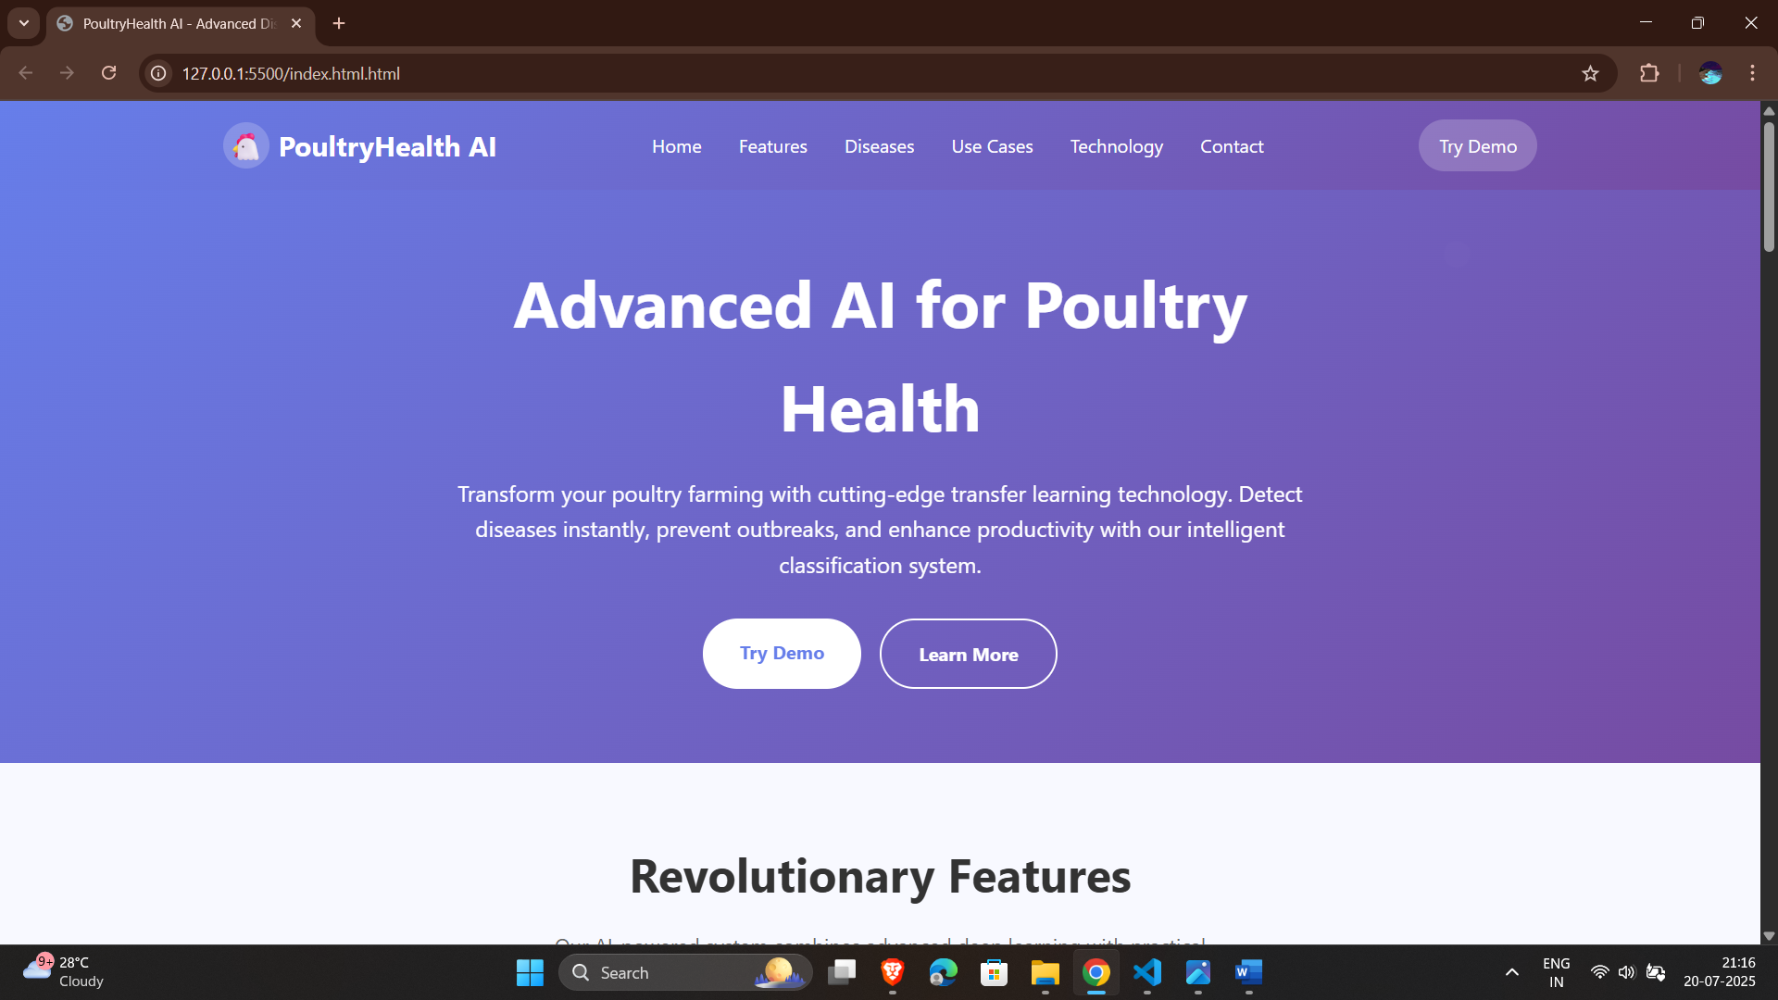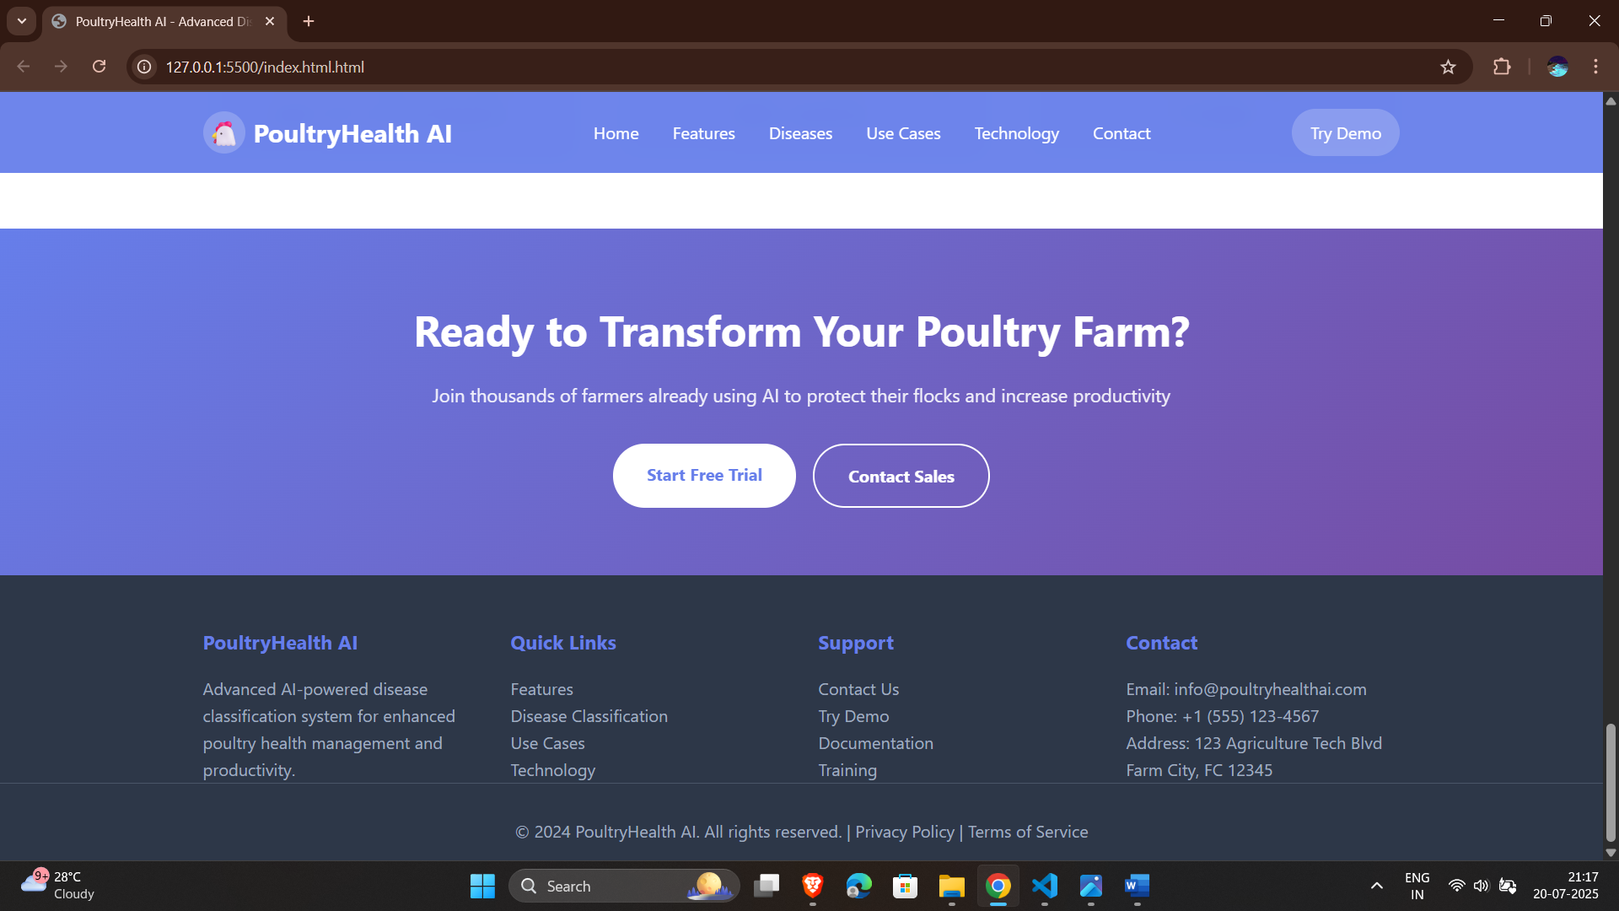

The final trained model was saved as .h5 format and integrated into the Flask application for real-time prediction.

Transfer Learning-Based Classification of Poultry Diseases This innovative project leverages transfer learning to develop a smart poultry disease classification system. The model categorizes poultry health into four conditions: Salmonella, New Castle Disease, Coccidiosis, and Healthy. The solution integrates machine learning with mobile technology, allowing farmers to input data such as symptoms, environmental factors, and biological observations. The goal is to provide immediate diagnosis and treatment guidance, improving poultry health outcomes and farm productivity.

Objectives and Methodology Key Objectives:- Build an accurate deep learning model using transfer learning techniques.- Classify diseases based on input data: symptoms, environmental conditions, biological

samples.- Deploy the model into a mobile application for ease of access by

farmers.- Recommend appropriate treatment and management strategies.

Methodology:- Use pre-trained CNNs (e.g., ResNet, MobileNet) for feature

extraction.- Fine-tune the model with poultry-specific

datasets.- Collect and label data from field experts and veterinary

sources.- Design a mobile interface for real-time user interaction and diagnosis.

Scenario 1: Outbreak in a Rural Community A rural village depends on backyard poultry farming as a primary income source. A sudden rise in sick birds causes panic. Symptoms

observed: lethargy, diarrhea, reduced egg production. No nearby veterinary services are available. Action:- Farmers use the mobile app to report symptoms and conditions.- The app classifies the illness as Coccidiosis using the

trained model.- Immediate treatment and preventive guidelines are provided.

Impact:- Quick response limits the disease

spread.- Saves livestock and farmer

income.- Enhances trust in digital health tools.

**Scenario 2:** Commercial Poultry Farm Management A commercial farm integrates the AI-based disease detection system as part of its health surveillance. Routine data collection reveals unusual symptoms in a segment of the flock. Action:- App identifies New Castle Disease through real-time

analysis.- Immediate isolation protocols are enacted.- Veterinary assistance is sought for confirmation and large-scale intervention.

Impact:- Outbreak contained withn hours.- Reduced financial loss and

mortality.- Reinforces value of proactive disease monitoring using technology. Scenario 3: Veterinary Training and Education Veterinary institutions adopt the mobile app as an educational tool for students. Students interact with real-world case data and hypothetical scenarios. The system simulates diagnoses based on input parameters, guiding them through logical reasoning and decision-making.

Features:- Access to disease

databases.- Simulated diagnostics with

feedback.- Exposure to current digital diagnostic tools.

Outcome:- Students gain confidence using AI-based

platforms.- Preparedness for fieldwork

improves.- Supports modern veterinary curriculum standards. Conclusion and Future Prospects This project successfully demonstrates the use of transfer learning and mobile AI to classify and manage poultry diseases.

Benefits:- Enhances early disease

detection.- Reduces dependency on in-person veterinary

services.- Improves poultry health and farmer productivity. Future

Directions:- Expand disease categories to include Avian Influenza, Infectious Bronchitis, etc.- Integrate image-based diagnostics using deep

CNN models.- Offer support in multiple

local languages.- Connect farmers with veterinarians and suppliers in-app. Vision: A smarter, healthier, and more sustainable poultry industry powered by AI.

-------------*** THANKYOU ***--------------